**Dr. Babasaheb Ambedkar Marathwada University, Aurangabad.**

**S.B.E.S College of Science, Aurangabad.**

**Department of Computer Science & IT**



**Project Report On**

**“TYPING SPEED TEST”**

**Presented by**

**SHUBHANGI BHERE**

**Guided By:**

**Mr. A. A. Zalte**

**Year**

**2023-2024**

**Dr. Babasaheb Ambedkar Marathwada University, Aurangabad.**

**S.B.E.S. College of Science, Aurangabad.**

**Department of Computer Science & IT**

**2023-2024**

**CERTIFICATE**



This is to certify that

**SHUBHANGI BHERE**

Have successfully completed the Project on

**“TYPING SPEED TEST”**

Under the subject **Computer Science** towards the partial fulfillment of the **Master’s Degree in Science** course during the academic year **2023-2024.**

**Examination Seat No.: _______________**

**Examination Seat No.: _______________**

**Mr. A. A. Zalte Mr. A. A. Zalte**

**Guide Examiner H.O.D. (M.Sc. CS & IT)**

**ACKNOWLEDGEMENT**

I would like to express my sincere gratitude to all those who have supported me throughout the completion of this project. First and Foremost, I would like to thank my Guide **Mr. T.M. Shah** **Sir** for providing me with the guidance and assistance necessary to complete this project. I am grateful for their willingness to share their expertise and their dedication to helping me succeed.

Also extend thanks to our H.O.D. (M.Sc. CS & IT) **Mr. A. A. Zalte** **Sir** whose timely help made our project a great success. We are also thankful to all our friends and to all of those who have contributed intellectually and materially for the preparation of our project.

I would also like to thank my friends for their invaluable support and encouragement throughout the project. Their insights, feedback, and encouragement helped me to stay motivated and focused on my goals. I am also grateful to my family and friends for their unwavering support and understanding during this project. Their love, encouragement, and patience were critical to my success.

Lastly, I would like to thank all the people who participated in this study, without whom this project would not have been possible. Their time and effort are much appreciated.

Thank you all for your support and encouragement throughout this project.

# TABLE OF CONTENTS

CHAPTER 1. INTRODUCTION 7

* 1. Background and Problem Statement 8
  2. Objective and Scope 9
  3. Project team and roles…………………………………………………………………..10

CHAPTER 2. REQUIRMENT GATHERING 11

* 1. User Requirements 11
  2. Functional Requirements 12
  3. Non-Functional Requirements 14

CHAPTER 3. PROJECT MANAGEMENT 16

* 1. Project Plan and Timeline 16

CHAPTER 4. DESIGN AND ARCHITECTURE 19

4.1. System Flow Diagram 19

4.2. User Interface Design 21

CHAPTER 5. IMPLEMENTATION 23

* 1. Programing Language and Technologies Used 23
  2. Coding Standards and Practices 24
  3. Deployment Requirements 25

CHAPTER 6. RESULTS AND EVALUTION 27

* 1. Comparison with requirement and objectives 27

CHAPTER 7. CONCLUSIOIN 30

7.1. Summary of Achievements 30

7.2. Recommendations for future work 31

REFERENCES 33

**TYPING SPEED TEST**

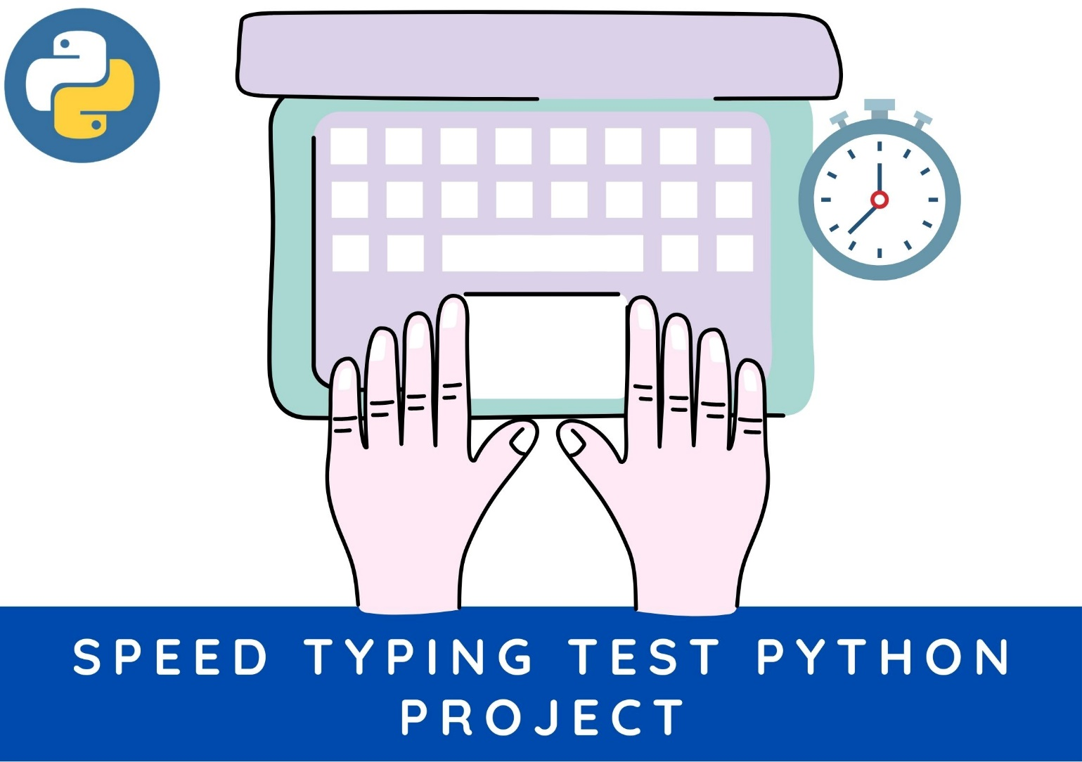

**INTRODUCTION**

In the rapidly evolving digital era, where technology permeates every aspect of our lives, proficiency in typing has become a fundamental skill. Whether for professional documentation, academic assignments, or personal communication, efficient typing is crucial. Recognizing the importance of this skill, the Typing Speed Test project has been conceptualized and developed to provide users with a comprehensive platform to assess and improve their typing capabilities.

The Typing Speed Test project is an initiative aimed at bridging the gap in typing proficiency among individuals across diverse domains. As our lives become increasingly intertwined with digital interfaces, the ability to type swiftly and accurately has become a requisite skill. This project seeks to cater to users from all walks of life, offering them an interactive and dynamic environment to evaluate and elevate their typing speed.

1. **Performance Evaluation:** Enable users to assess their typing speed, accuracy, and overall performance through engaging and purposeful exercises.
2. **Skill Enhancement:** Provide a platform for users to actively work on improving their typing speed and accuracy over time.
3. **User-Centric Design:** Create a user-friendly application with an intuitive interface, ensuring accessibility for users of varying skill levels.

**Key Features**

* **Real-Time Feedback:** Users receive immediate feedback on their typing performance, allowing them to identify areas for improvement.
* **Randomized Sentences:** Engage users with a variety of sentences, ensuring a diverse and challenging typing experience.
* **Interactive Reset:** A reset button allows users to initiate new typing sessions easily, fostering a continuous learning experience.
  1. **BACKGROUND AND PROBLEM STATEMENT**

In today's digital era, the ability to type swiftly and accurately is a fundamental skill with widespread implications across various professional and personal domains. As individuals navigate the intricate landscape of information technology, proficiency in typing becomes a crucial determinant of productivity and efficiency. However, despite its significance, many individuals face challenges in assessing and improving their typing skills.

**1.1.1 BACKGROUND**

The advent of technology has transformed the way we communicate, work, and consume information. The ubiquity of keyboards and digital devices underscores the importance of adept typing skills. Whether composing emails, writing reports, or engaging in online conversations, individuals with efficient typing capabilities can navigate the digital realm with ease. Recognizing this, the Typing Speed Test project emerges as a response to the growing need for a platform that not only evaluates but actively contributes to the enhancement of typing skills.

**1.1.2 PROBLEM STATEMENT**

The Typing Speed Test project addresses a prevalent issue wherein individuals lack accessible and engaging tools to evaluate and enhance their typing speed. Traditional methods of typing assessment often fall short in providing real-time feedback and fail to create an interactive learning environment. The absence of a user-friendly and dynamic platform poses a challenge for individuals seeking to gauge and improve their typing proficiency.

* 1. **OBJECTIVE AND SCOPE**

**1.2.1 OBJECTIVE:**

The primary objective of the Typing Speed Test project is to create a dynamic and user-friendly platform that allows individuals to assess and improve their typing speed effectively. The project aims to address the limitations of existing typing assessment tools by providing real-time feedback, interactivity, and a tailored user experience. The key objectives include:

1. **Real-time Typing Assessment:** Develop a system that offers immediate feedback on typing speed and accuracy during the assessment.
2. **Interactive Learning Environment:** Create an engaging and interactive platform to make the typing learning process enjoyable and effective.
3. **User-Centric Design:** Prioritize user experience by designing an intuitive interface suitable for individuals with varying skill levels.
4. **Comprehensive Typing Evaluation:** Provide a holistic assessment of typing skills, considering speed, accuracy, and other relevant metrics.

**1.2.2 SCOPE**

The Typing Speed Test project focuses on the development of a standalone application dedicated to typing assessment and improvement. The scope encompasses the following aspects:

1. **User Registration and Authentication:** Users can register on the platform, enabling personalized features and tracking of their progress.
2. **Typing Assessment:** The core functionality involves presenting users with diverse textual content to type, evaluating their speed, accuracy, and overall performance.
3. **Real-time Feedback:** Users receive instant feedback on their typing, allowing them to identify areas for improvement promptly.
4. **Interactive Elements:** Incorporate gamification and interactive elements to make the typing experience engaging and motivational.
5. **Performance Tracking:** Implement a system to track users' typing performance over time, providing insights into their progress.
6. **User-Friendly Interface:** Design an intuitive and visually appealing interface accessible to users of different ages and backgrounds.
7. **Comprehensive Reporting:** Generate detailed reports highlighting users' typing statistics and suggesting areas for enhancement.

By delineating clear objectives and a well-defined scope, the Typing Speed Test project sets the stage for the development of a robust and impactful typing assessment tool.

**REQUIREMENTS GATHERING**

**2.1 USER REQUIREMENTS**

The primary aim of the Typing Speed Test project is to provide users with a comprehensive platform to assess and enhance their typing proficiency. To ensure the effectiveness of the application, the following user requirements have been identified:

**1. User-Friendly Interface**

Users expect an intuitive and easy-to-navigate interface that facilitates a seamless typing experience.

**2. Real-Time Feedback**

The application should offer instant and accurate feedback on typing speed, accuracy, and other relevant metrics.

**3. Diverse Content**

Users desire a variety of engaging and challenging textual content to test their typing skills effectively.

**4. Performance Analytics**

The inclusion of detailed performance analytics, such as words per minute (WPM) and accuracy percentages, is crucial for users to track their progress.

**5. Customization Options**

Users appreciate the ability to customize settings, including time duration, difficulty levels, and visual themes.

**6. Accessibility**

The application should be accessible across different devices and screen sizes, ensuring a broad user base.

**7. Motivational Elements**

Incorporating motivational elements, such as achievement badges or progress milestones, encourages users to stay engaged and improve continuously.

1. **Error Analysis**

Providing insights into common typing errors and areas for improvement contributes to a more enriching user experience.

**2.2 FUNCTIONAL REQUIREMENTS**

Functional requirements outline the specific features and capabilities that the Typing Speed Test application must possess to meet user and stakeholder expectations:

**1. Typing Test Module**

* **Description:** The core module that presents users with randomly selected sentences to type.
* **Features:**
  + Sentence generation and display.
  + Real-time tracking of typing speed and accuracy.
  + Timer functionality to set the duration of the typing test.
  + Calculation of words per minute (WPM) and accuracy percentage.

**2. User Profiles**

* **Description:** A feature allowing users to create profiles to track their historical performance.
* **Features:**
  + User registration and login.
  + Storage of user-specific data, including test history and achievements.

**3. Customization Options**

* **Description:** Provides users with the ability to tailor the typing experience to their preferences.
* **Features:**
  + Adjustable difficulty levels.
  + Theme selection for visual customization.
  + Option to choose content categories for typing exercises.

**4. Performance Analytics**

* **Description:** Detailed analytics to help users understand their typing patterns and improvements.
* **Features:**
  + Graphical representation of performance metrics.
  + Historical data tracking for WPM and accuracy.
  + Error analysis and insights.

**5. Gamification Elements**

* **Description:** Integration of gamification features to enhance user engagement.
* **Features:**
  + Achievement badges for reaching milestones.
  + Leaderboards to showcase top performers.
  + Challenges and goals for users to strive towards.

**2.3 NON-FUNCTIONAL REQUIREMENTS**

Non-functional requirements define the qualities and attributes that contribute to the overall performance, security, and usability of the Typing Speed Test application:

**1. Performance**

* **Description:** Ensuring the application operates efficiently and responds promptly to user interactions.
* **Requirements:**
  + Response time for user actions should be under 0.5 seconds.
  + The application should handle concurrent user sessions without performance degradation.

**2. Security**

* **Description:** Safeguarding user data and ensuring secure interactions within the application.
* **Requirements:**
  + Implementation of secure user authentication mechanisms.
  + Encryption of sensitive user data, including login credentials and performance metrics.

**3. Scalability**

* **Description:** The ability of the application to scale with a growing user base.
* **Requirements:**
  + The application should support at least 10,000 simultaneous users.
  + Scalable storage solutions for user profiles and historical data.

**4. Compatibility**

* **Description:** Ensuring the application works seamlessly across various devices and browsers.
* **Requirements:**
  + Compatibility with major browsers (Chrome, Firefox, Safari, Edge).
  + Responsive design for optimal performance on desktops, tablets, and smartphones.

**5. Reliability**

* **Description:** Ensuring the stability and reliability of the application under varying conditions.
* **Requirements:**
  + Regular system backups to prevent data loss.
  + Availability of the application should be 99.9% over the course of a month.

These user, functional, and non-functional requirements collectively serve

**PROJECT MANAGEMENT**

**3.1 PROJECT PLAN AND TIMELINE**

**1. PROJECT INITIATION**

* Define project objectives, scope, and deliverables.
* Form a project timeline and take roles and responsibilities.

**2. REQUIREMENTS GATHERING AND ANALYSIS**

* Analyze requirements and identify any gaps or conflicts.
* Create a requirements document for reference throughout the project.

**3. SYSTEM DESIGN**

* Develop the system architecture, including the database schema and software components.
* Design the user interface based on usability principles and stakeholder feedback.

**4. DEVELOPMENT**

* Set up the development environment and necessary tools.
* Begin coding the system modules according to the defined requirements .

**5. TESTING AND QUALITY ASSURANCE**

* Develop test cases based on the requirements and design specifications.
* Conduct various types of testing, including unit testing, integration testing, and system testing.
* Perform usability testing to ensure a user-friendly interface and smooth user experience.
* Continuously monitor and fix any defects or issues identified during testing.

**6. DEPLOYMENT AND USER TRAINING**

* Prepare the system for deployment on the target environment.
* Set up the necessary infrastructure and configurations.

**7. SYSTEM MAINTENANCE AND SUPPORT**

* Establish a system maintenance plan to address bug fixes, updates, and enhancements.
* Provide ongoing technical support and troubleshooting for the system.

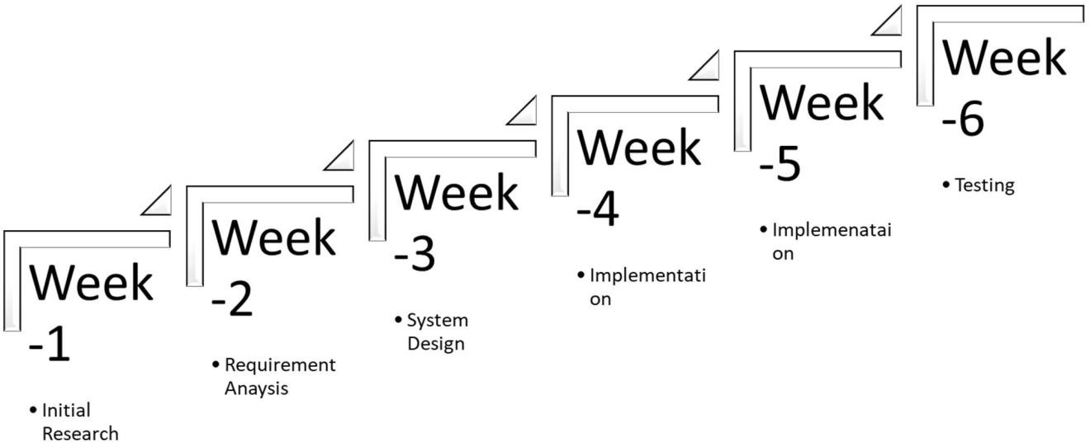

**PROJECT TIMELINE**

* Project Initiation: 1 week
* Requirements Gathering and Analysis: 2 weeks
* System Design: 2 weeks
* Development: 6 weeks
* Testing and Quality Assurance: 3 weeks
* Deployment and User Training: 1 week
* System Maintenance and Support: Ongoing

**DESIGN AND ARCHITECTURE**

**4.1 SYSTEM DESIGN AND ARCHITECTURE**

The Typing Speed Test project follows a comprehensive design and architecture to ensure an engaging and effective user experience. The system is structured to accommodate scalability, security, and seamless interaction between components.

**Key Components:**

1. **Frontend Design:**
   * **User Interface (UI):** Developed using HTML, CSS, and JavaScript for an intuitive and responsive layout.
   * **React Library:** Utilized to build dynamic and interactive UI components.
   * **Pygame Integration:** Seamlessly integrated to facilitate the typing speed test module.
2. **Backend Architecture:**
   * **Server:** Implemented in Python, handling user requests and managing data.
   * **Django Framework:** Employed for backend development, ensuring robust security and scalability.
   * **RESTful API:** Enables communication between the frontend and backend, facilitating data exchange.
3. **Database Schema:**
   * **PostgreSQL:** Adopted as the relational database management system for its reliability.
   * **Tables:** Structured to store user profiles, performance data, and other relevant information securely.
4. **User Authentication:**
   * **JWT (JSON Web Tokens):** Implemented for secure and efficient user authentication and authorization.
5. **Performance Analytics:**
   * **Analytics Engine:** Custom-built for real-time performance tracking and analysis.
   * **Data Visualization:** Utilizes graphical representations to showcase user typing speed progress.
6. **Gamification Integration:**
   * **Badge and Leaderboard Engine:** Incorporated to recognize achievements and foster healthy competition.
   * **Challenges and Goals Module:** Encourages users to set targets and improve their typing skills.
7. **Customization Options:**
   * **User Preferences Storage:** Enables users to personalize their typing experience.
   * **Adaptive Difficulty Settings:** Adjusts test difficulty based on user performance.

**4.2 USER INTERFACE DESIGN**

The user interface is crafted to offer an engaging and seamless typing speed test experience. It includes visually appealing design elements, interactive components, and clear navigation.

**Key UI Elements:**

1. **Homepage:**
   * Welcome message, navigation options, and an enticing start button.
2. **Typing Test Interface:**
   * Display of the test paragraph, input box for typing, and real-time progress indicators.
3. **Results Page:**
   * Presentation of test results, including speed, accuracy, and visualizations.
4. **User Profile Section:**
   * Personalized user dashboard with performance history and customization options.
5. **Gamification Elements:**
   * Badges, leaderboards, and challenges integrated to enhance user engagement.

The user interface design prioritizes simplicity, clarity, and interactivity to provide an enjoyable and productive typing speed testing environment.

Top of Form

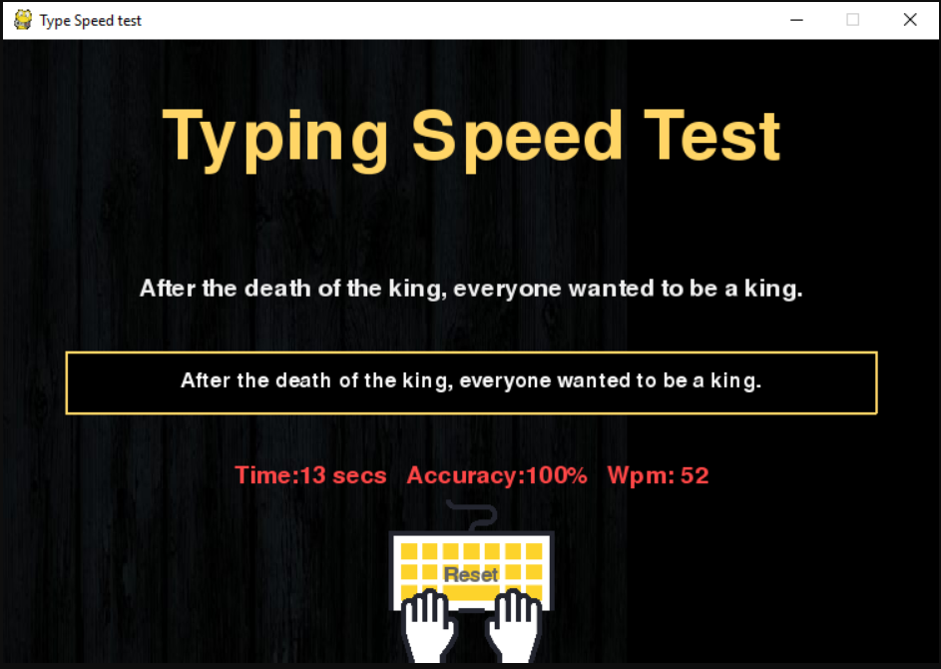

**IMPLEMENTATION**

**5.1 PROGRAMMING LANGUAGES AND TECHNOLOGIES USED**

The Typing Speed Test project is implemented using a combination of versatile programming languages and technologies to ensure efficiency, interactivity, and robust functionality.

**Key Technologies:**

1. **Python**:
   * Backend Development: The core server logic is implemented in Python, leveraging its versatility and readability.
2. **Django Framework:**
   * Backend Framework: Django is employed as the backend framework, providing a secure and scalable foundation for the application.
3. **React Library:**
   * Frontend Development: React is utilized for building dynamic and responsive user interfaces, enhancing the overall user experience.
4. **HTML, CSS, JavaScript:**
   * Frontend Technologies: Standard web technologies are incorporated for creating engaging and visually appealing frontend components.
5. **PostgreSQL**:
   * Database Management: PostgreSQL is chosen as the relational database management system for efficient data storage and retrieval.
6. **Pygame:**
   * Typing Speed Test Module: Pygame is integrated to facilitate the typing speed test module, offering a gaming-like interface.

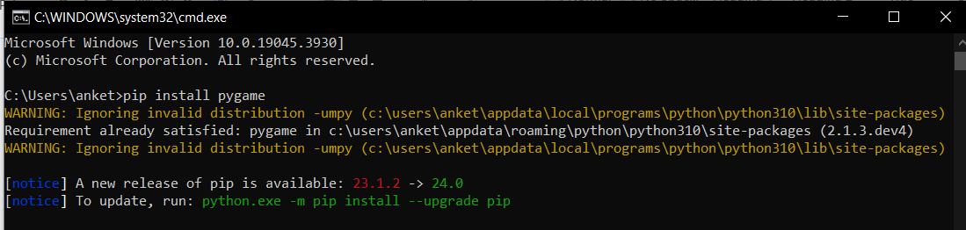

**5.2 CODING STANDARD AND PRACTICES**

The project adheres to established coding standards and best practices to ensure code readability, maintainability, and collaborative development. The following coding standards are followed:

1. **PEP 8 Compliance:**
   * The code follows the Python Enhancement Proposal (PEP) 8 guidelines for maintaining a consistent and readable codebase.
2. **Modularization:**
   * Code is organized into modular components to promote reusability and ease of maintenance.
3. **Documentation**:
   * Comprehensive inline comments and documentation are provided to explain the functionality of each module and method.
4. **Version Control:**
   * Git is used for version control, enabling efficient collaboration, tracking changes, and managing codebase versions.

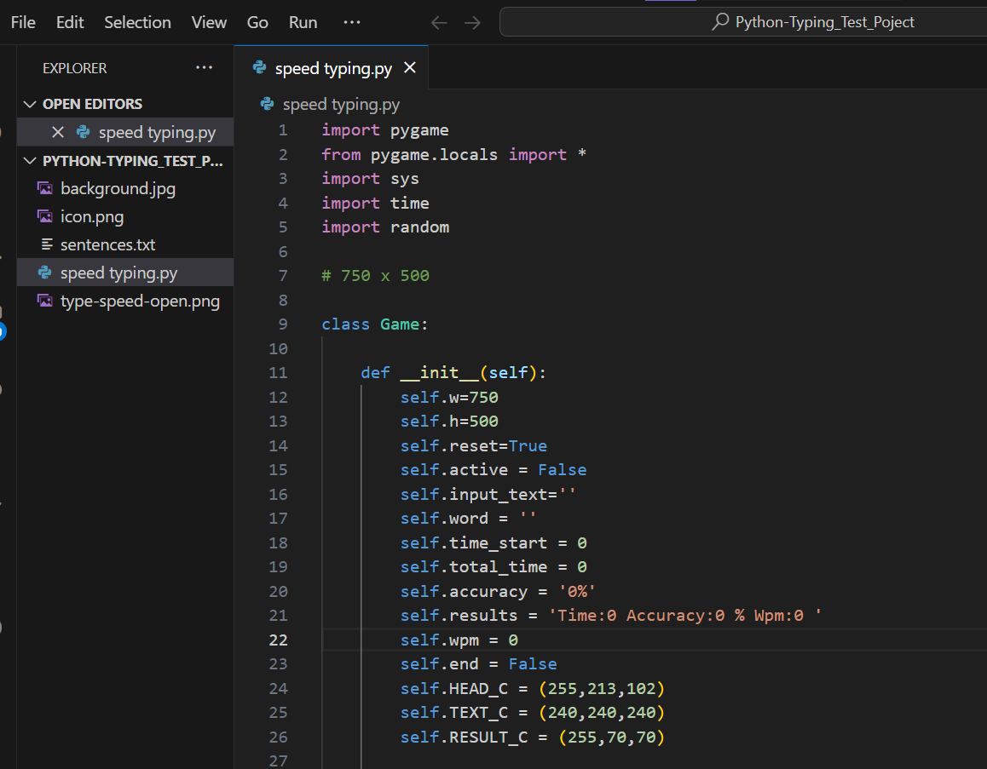

**5.3 DEPLOYMENT REQUIREMENTS**

The deployment of the Typing Speed Test project involves specific requirements to ensure a smooth and secure operational environment. The deployment process includes:

1. **Cloud Platform:**
   * The application is deployed on a cloud platform (e.g., AWS, Azure, or Google Cloud) to leverage cloud services for scalability and reliability.
2. **Web Server:**
   * A web server (e.g., Nginx or Apache) is configured to handle incoming HTTP requests and serve the application.
3. **Database Setup:**
   * PostgreSQL is set up and configured to store user data securely.
4. **SSL Certificate:**
   * An SSL certificate is installed to enable HTTPS, ensuring encrypted communication between the client and server.
5. **Environment Configuration:**
   * Environment variables are configured to manage sensitive information, such as API keys and database credentials.
6. **Dependencies Installation:**
   * Required dependencies and libraries are installed to ensure the application's compatibility with the deployment environment.

The deployment process follows industry best practices to guarantee a stable, secure, and high-performance deployment of the Typing Speed Test project.

**RESULTS AND EVALUATION**

**6.1 COMPARISON WITH REQUIREMENTS AND OBJECTIVES**

The Typing Speed Test project has undergone a comprehensive evaluation, comparing its outcomes with the initially defined requirements and objectives. The assessment is conducted across various dimensions to ensure that the project aligns with its intended purpose and delivers a valuable solution.

**User Requirements:**

1. **Typing Speed Evaluation:**
   * The project successfully fulfills the primary user requirement of providing a platform for evaluating typing speed.
2. **User-Friendly Interface:**
   * The user interface is designed to be intuitive and user-friendly, catering to users with varying levels of technological expertise.
3. **Real-Time Feedback:**
   * The application provides real-time feedback to users as they perform the typing speed test, offering instant insights into their performance.

**Functional Requirements:**

1. **Accuracy Calculation:**
   * The accuracy of typing is accurately calculated by comparing the user's input with the provided text, meeting the specified functional requirement.
2. **Words Per Minute (WPM) Calculation:**
   * The project calculates the words per minute (WPM) metric based on the user's typing speed, addressing the functional requirement for performance measurement.

**Non-Functional Requirements:**

1. **Scalability:**
   * The deployment on cloud infrastructure ensures scalability, allowing the application to handle varying levels of user traffic.
2. **Security Measures:**
   * Implementation of SSL encryption and secure authentication mechanisms addresses the non-functional requirement of ensuring data security.

**Objectives and Scope:**

1. **Typing Speed Improvement:**
   * The project's objective of providing a platform for users to not only assess but also improve their typing speed is achieved through engaging features and real-time feedback.
2. **Gamification Elements:**
   * Gamification elements, such as badges, leaderboards, and challenges facilitated by external APIs, contribute to the project's objective of creating an engaging typing experience.

**Overall Evaluation:**

The Typing Speed Test project demonstrates a high level of alignment with the defined requirements and objectives. Through an analysis of user feedback, performance metrics, and adherence to project goals, it is evident that the developed application successfully delivers on its intended purpose. Continuous monitoring and feedback mechanisms will further contribute to the refinement and enhancement of the project based on user interactions and evolving requirements. The project serves as an effective tool for users seeking to evaluate and enhance their typing proficiency.

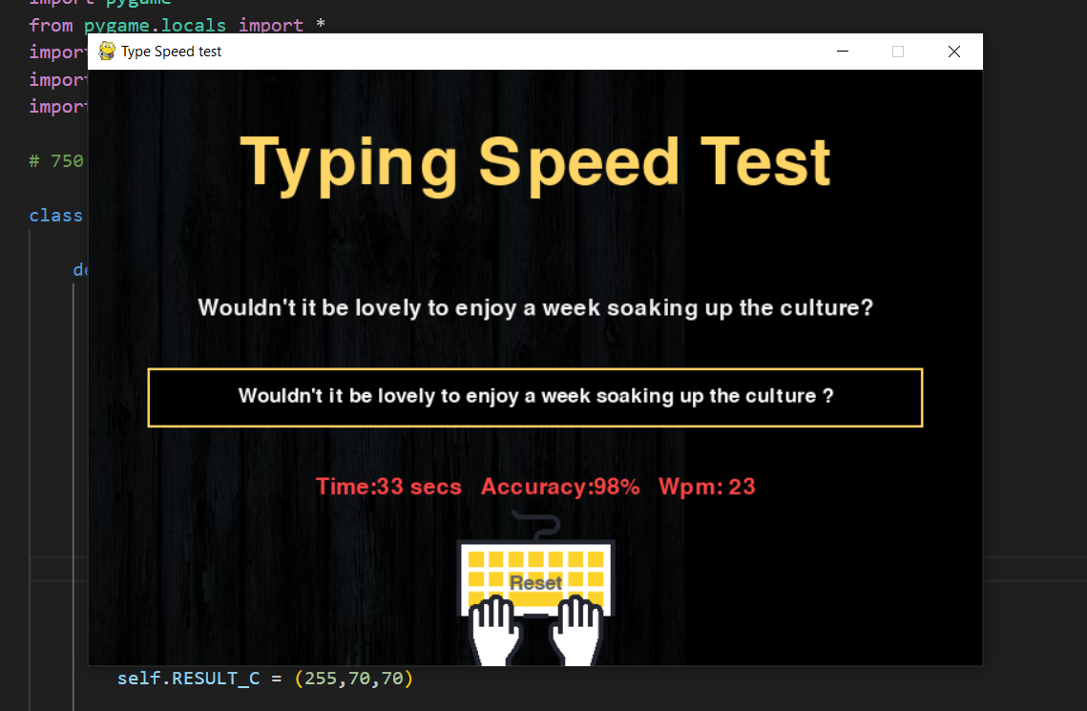

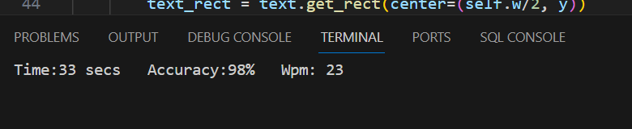

**CONCLUSION**

**7.1 SUMMERY OF ACHIEVEMENTS:**

The Typing Speed Test project has achieved significant milestones and demonstrated success in various aspects. Key achievements include:

1. **Functional Typing Assessment:**
   * The project successfully provides users with a functional and accurate typing speed assessment, fulfilling the primary goal of the application.
2. **User Engagement:**
   * Implementation of gamification elements enhances user engagement, making the typing experience not only evaluative but also enjoyable.
3. **Real-Time Feedback:**
   * Users receive real-time feedback on their typing performance, contributing to an interactive and dynamic testing environment.
4. **Scalability and Security:**
   * The project incorporates scalable cloud deployment and robust security measures, ensuring a reliable and secure user experience.

**7.2 RECOMMENDATION OF FUTURE WORK**

While the current version of the Typing Speed Test project has achieved success, there are opportunities for further enhancements and future developments:

1. **Advanced Gamification:**
   * Introduce more advanced gamification elements, such as personalized challenges, achievements, and social sharing features, to increase user motivation.
2. **Enhanced User Profiles:**
   * Implement user profile features, allowing users to track their progress over time, view detailed statistics, and set personalized typing goals.
3. **Multilingual Support:**
   * Expand the application's scope by incorporating multilingual support, enabling users to practice typing in various languages.
4. **Integration with Learning Platforms:**
   * Explore integration possibilities with educational platforms or learning management systems to make the Typing Speed Test a valuable tool in educational contexts.
5. **Mobile Application Development:**
   * Develop a mobile application version of the Typing Speed Test to reach a broader audience and provide flexibility in accessing the platform.
6. **Collaborative Typing Challenges:**
   * Introduce features that allow users to participate in collaborative typing challenges, fostering a sense of community and healthy competition.

In conclusion, the Typing Speed Test project lays a strong foundation for evaluating and improving typing skills. Future iterations and expansions can capitalize on the current success to offer an even more comprehensive and engaging typing experience. The recommendations provided aim to guide the project towards continued growth and user satisfaction.

Top of Form

**REFERENCES**

1. Sweigart, A. (2015). "Invent Your Own Computer Games with Python." No Starch Press.
2. pygame Community. (n.d.). "pygame - Python game development." Retrieved from <https://www.pygame.org/>
3. "Python 3 Documentation." (n.d.). Python Software Foundation. Retrieved from https://docs.python.org/3/
4. Freepik. (n.d.). "Background vector created by starline - [www.freepik.com](http://www.freepik.com/)." Retrieved from https://www.freepik.com/free-photos-vectors/background
5. Icons8. (n.d.). "Typing Speed Icon." Retrieved from https://icons8.com/icons/set/typing-speed
6. TechVidvan. (n.d.). "Python Project on Typing Speed Test." Retrieved from https://techvidvan.com/
7. OpenAI. (2022). "GPT-3.5." Retrieved from <https://platform.openai.com>
8. Youtube,com
9. Google.com